SAMPLE SALES DATASET ANALYSIS
This analysis was done on a retail sales dataset to understand revenue performance, customer behavior, product contribution and market distribution across countries. The dataset represents a multi-country wholesale retail operation with product lines spanning classic cars, vintage cars, motorcycles, planes, trucks and other transport-related categories.
When I analyzed the REVENUE PERFORMANCE over time, I realized seasonal trends in revenue generation. The highest revenue month recorded was November 2004, generating approximately $1.09M in sales with 301 orders. The revenue fluctuates across months but shows periodic spikes, indicating strong seasonal purchasing behavior. The business demonstrates consistent transactional activity across the dataset period (2003 – 2005). Revenue is not evenly distributed across time as peak periods significantly outperform average months.
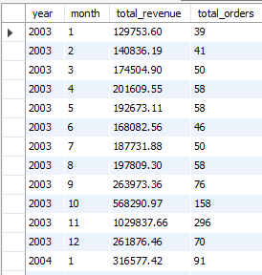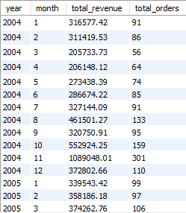
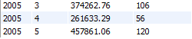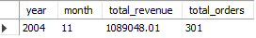

Moving on from there to COUNTRY/REGIONAL PERFORMANCE, I noticed that revenue is heavily concentrated in a small number of countries. The United States is the dominant market with over $3M+ in revenue and 1,004 orders. Spain is the second-largest market with approximately $1.2M in revenue. Other countries include France, Australia, UK, Italy, Germany, Japan, Canada, Philippines. There is no representation from South America or Africa, indicating a geographically limited market distribution. This shows the business is highly dependent on western markets, especially the United States.
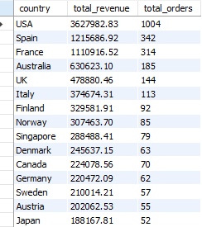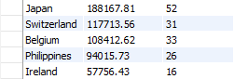

For PRODUCT LINE PERFORMANCE, we see the differences in both volume and value contribution. Classic cars are the top-performing product line, with the highest revenue of up to $4M and highest order of 967 orders. Vintage Cars, Trucks and Buses and Motorcycles contribute strong revenue but with lower order volumes indicating higher value per transaction. Ships and trains are the weakest performing product categories in terms of revenue and demand.
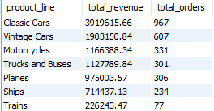
During CUSTOMER ANALYSIS, I found out that customer revenue distribution is highly skewed toward a few key accounts. Euro Shipping channel (~$902K) and Mini Gifts Distributors Limited (~654K) are the top two customers. A sharp revenue drop is observed after the top two customers, with the rest contributing significantly lower individual revenue. This evidently shows revenue is heavily dependent on a small number of high-value distributors. This also means that loss of either Euro Shopping Channel or Mini Gifts Distributors would materially impact overall business performance.
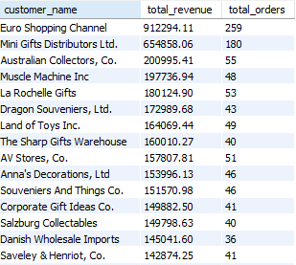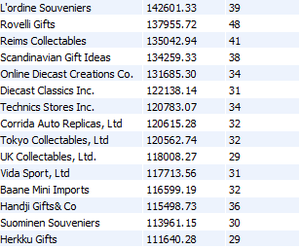
I segmented customers based on revenue contribution. The VIP customers contribute disproportionately to total revenue while the remaining customers form a Regular segment with significantly lower individual revenue contributions. 